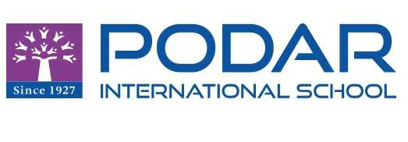**PODAR INTERNATIONAL SCHOOL (C.B.S.E), AURANGABAD**

**YEAR 2021-2022**

**Certificate**

This is to certify that this file contains bonafide practical work of Mr/Miss……………………………………………………………………………. Roll.No………………..….. student of the Podar International School (CBSE) Aurangabad, studying in Grade 12. He/She has completed his/her practical word satisfactorily during the academic session 2021-22.

Place: PIS-CBSE, A’BAD

Date:

Signature of Subject Teacher

Signature of External Examier